Created - Train And Test Folders

**Team ID:** PNT2022TMID50449 **Project Name:** Real time communication system powered by AI for specially abled

Stage 1: D:\IBM PROJECT – AI

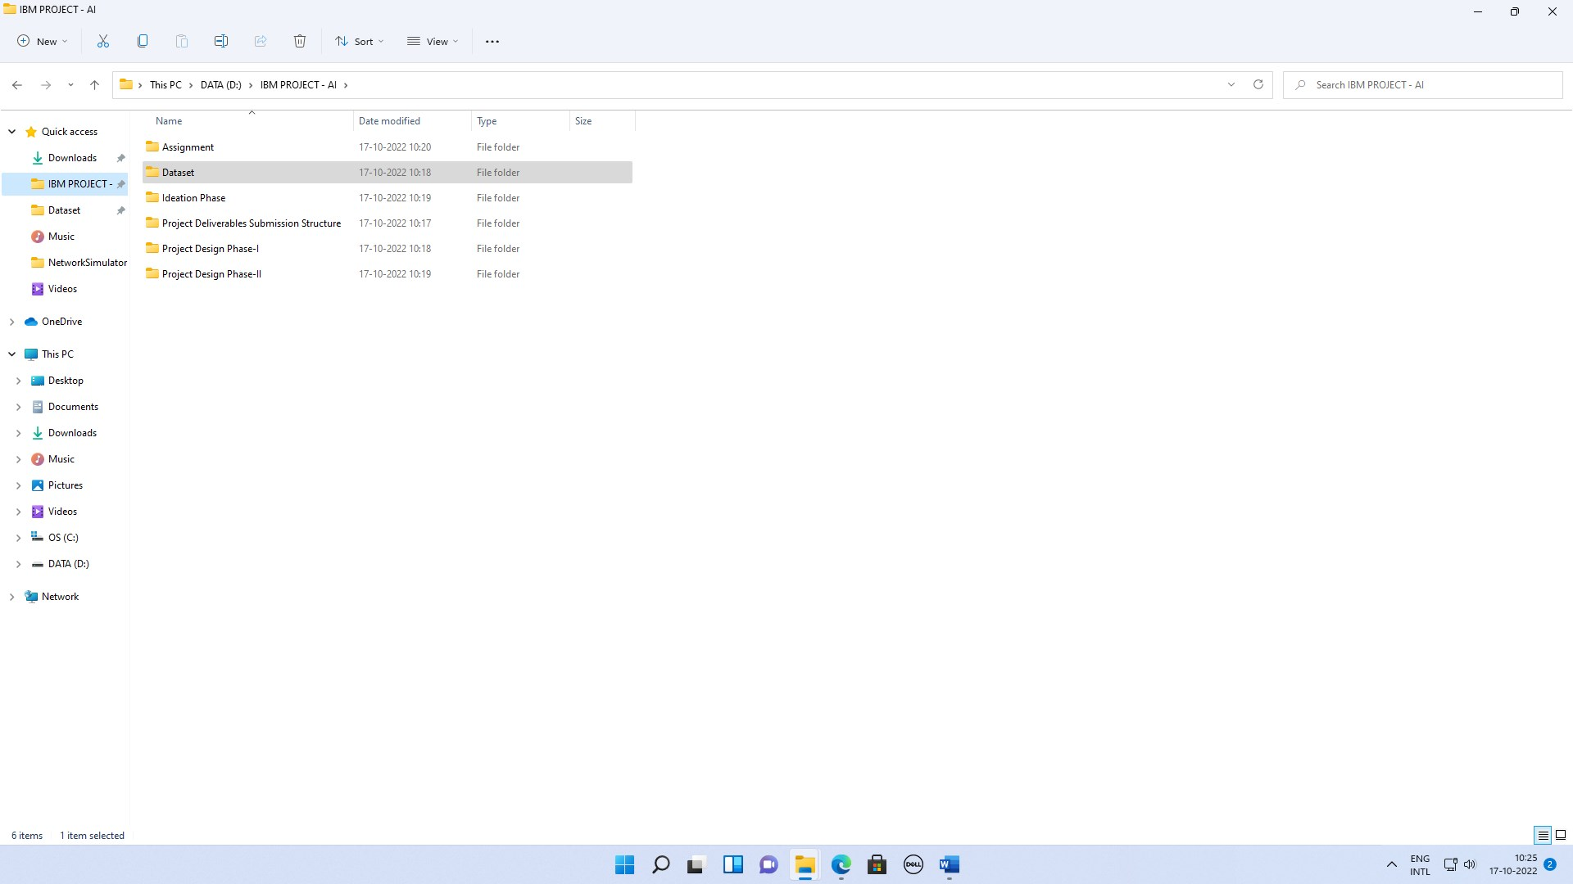

AI\Dataset

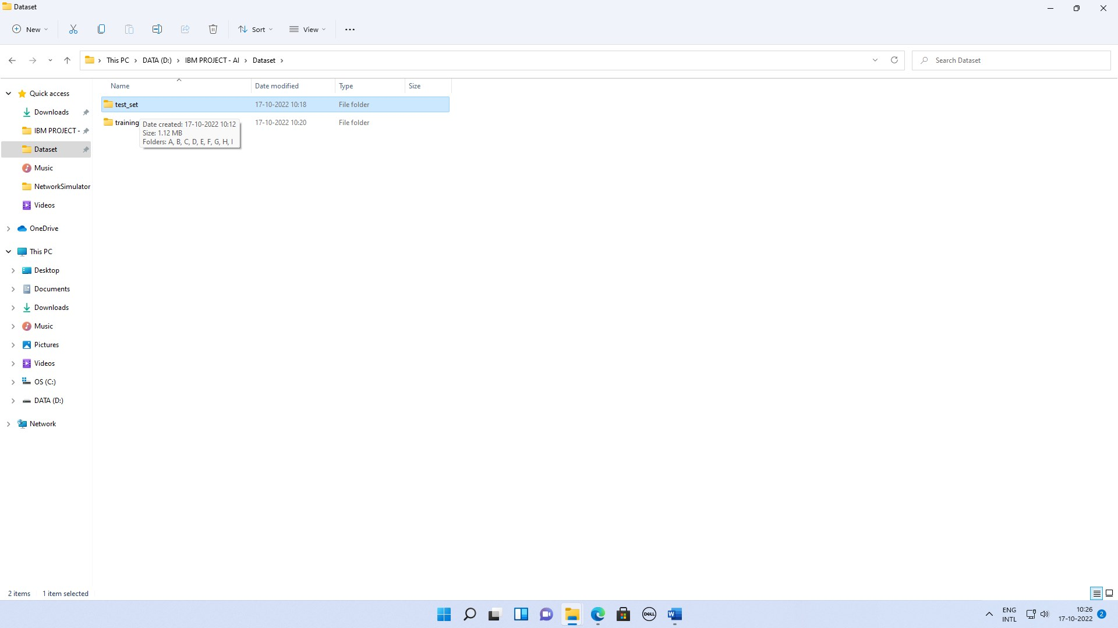

AI\Dataset\test_set\D

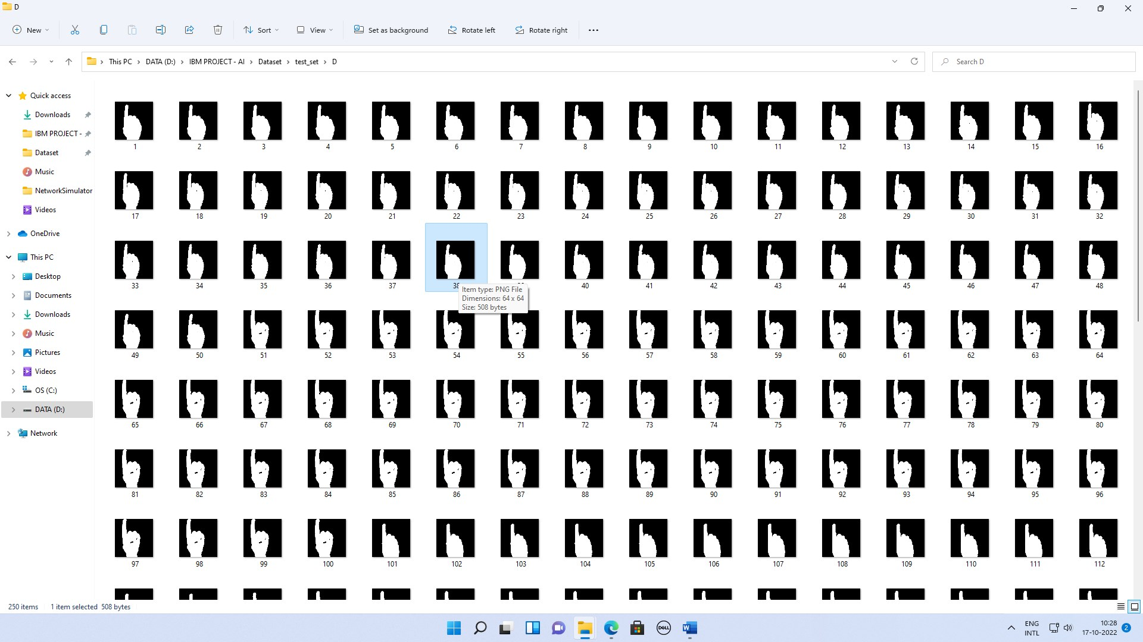

AI\Dataset\training_set\B

